Homework 1:
Design a speed-controlled dc motor drive maintaining the field flux constant. The motor parameters and ratings are as follows:
220V, 8.3A, 1470 rpm, R_{a} = 4Ω, J = 0.0607 kg-m², L_{a} = 0.072H, B_{t} = 0.0869 N·m/rad/sec, K_{b} = 1.26 V/rad/sec.
The inverter is supplied from 230V, 3-phase as at 60Hz. The converter is linear, and its maximum control input voltage is ±10 V. The tachogenerator has the transfer function $G_{ω}=\frac{0\text{.}\text{065}}{(1+0\text{.}\text{002}s)}$. The speed reference voltage has a maximum of 10 V. The maximum current permitted in the motor is 20A.
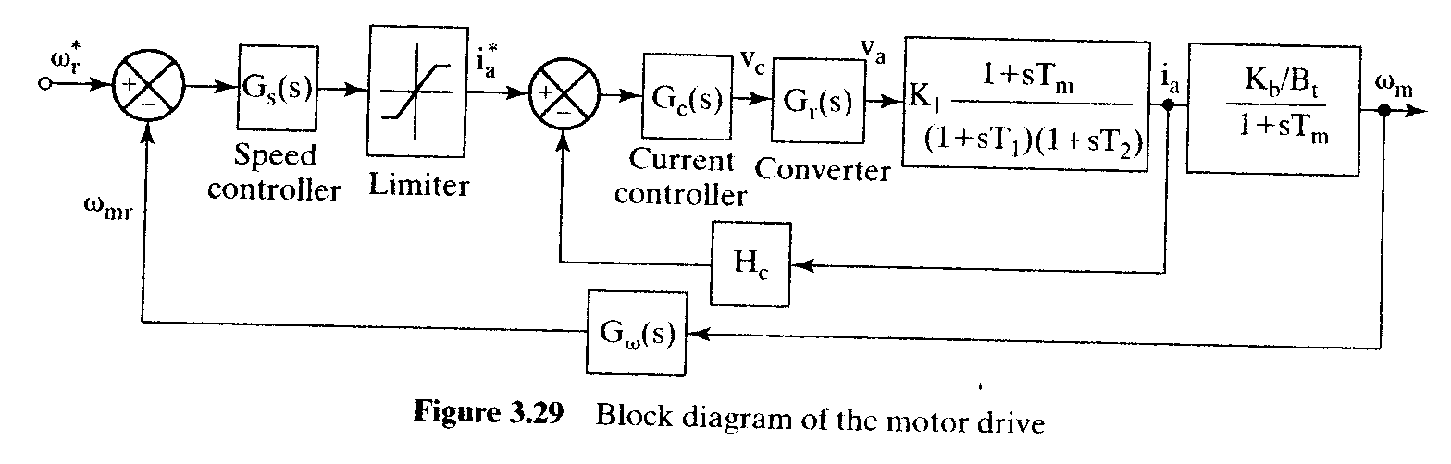
Referring Example 3.6 in page 83 finish the followings:
- Implement your design with MATLAB for demonstration,
- Design the speed controller uses the tools you know, such as root locus, PID controller, phase lead compensator, or phase lag compensator, and so on, to decide appropriate parameters. And then discussing your design associates with simulation results by MATLAB.

