英文節錄自: Jane http://etext.lib.virginia.edu/toc/modeng/public/BroJanI.html
中文節錄自: 簡愛 (兒童版)
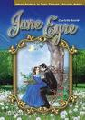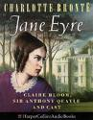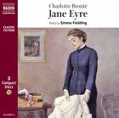
Jane Eyre Picture Source: Retrieved May 14, 2008, from
http://images.google.com.tw/images?um=1&complete=1&hl=zh-TW&rlz=1T4SKPB_enTW229TW229&q=Jane+Eyre&start=20&sa=N&ndsp=20

Word Number of SL: 1940
Word Number of TL: 2254
Total: 4194
Connective Types | Example Sentences
Temporal Connectives  (when, after that, then, after a while, later) | None
Contrastive Connectives  (but, however, but, on the contrary, nevertheless) | For one thing, I have no father or mother, brothers or sisters.  在 我 的 記 憶 中 ， 沒 有 留 下 父 母 的 印 象 ， 但 (added) 我 深 深 地 懷 念 他 們 。
Causal Connectives  (because, due to , so, thus, therefore, as a result) | None
Coordinate Connectives  (and, or) | None
Conditional Connectives  (if, provided that, although/though, only if) | Besides, school would be a complete change: it implied a long journey, an entire separation from Gateshead, an entrance into a new life.  只 要 (added) 有 地 方 可 去 ， 我 立 刻 就 離 開 這 兒 ,也 許 可 以 想 辦 法 送 你 去 上 學 。

